

**U24V210 SEA-2 / SAA-2 SOCIAL EMPOWERMENT ACTIVITY-2 / SELF ACCOMPLISHMENT ACTIVITY-2**

**Report**

**on**

**SA301: Physical Fitness**

***by***

***Mohammed Saifuddin***

***B24CS221***

***Under the guidance of***

***Indoor Stadium,***

***KITSW***



**KAKATIYA INSTITUTE OF TECHNOLOGY & SCIENCE, WARANGAL** *(An Autonomous Institute under Kakatiya University, Warangal)*

**(2024-25)**

*page i*

**KAKATIYA INSTITUTE OF TECHNOLOGY & SCIENCE, WARANGAL** *(An Autonomous Institute under Kakatiya University, Warangal)*

**CERTIFICATE**



*(issued by nodal centre)*

This is to certify that, **MOHAMMED SAIFUDDIN** bearing **Roll No. B24CS221,** student of

B.Tech, **CSE**, II Semester has successfully completed the activity SA-301 Physical Fitness under the mentorship of Indoor stadium, KITS, Warangal.

**Faculty Counsellor** **Mentoring Centre, SEA/SAA** **Institute Coordinator, SEA/SAA**

*page ii*

**ACKNOWLEDGEMENT**



I would like to express my deepest gratitude to my faculty counsellor, **Dr. Swapna Saturi**, **Professor,** Department of CSE, Kakatiya Institute of Technology & Science, Warangal, for his invaluable guidance, support, and encouragement throughout the activity.

I also extend my sincere thanks to the **Dr. M.S. Reddy**, **faculty** for their insights and expertise which have been instrumental in shaping the outcome of my work. which provided the necessary resources and facilities to carry out this work. The support of the entire team at the centre has been greatly appreciated.

I am deeply grateful to the experts I had the privilege to interact with, including **M.S. Reddy, Assistant professor** whose knowledge and advice significantly contributed to the development of this project.

Last but not least I wish to thank my friends and seniors who helped me directly or indirectly in the successful completion of this work.

***MOHAMMED SAIFUDDIN***

***B24CS221***

*Report on SEA-2/SAA-2* *U24VA210 SEA-2/SAA-2*

**CONTENTS**

| **Chapter** |  |  |  | **Chapter Title** | **Page** |
| --- | --- | --- | --- | --- | --- |
| **No.** |  |  |  | **number** |
|  |  |  |  |
|  |  |  |  | Certificate | i |
|  |  |  |  |  |  |
|  |  |  |  | Acknowledgement | ii |
|  |  |  |  | |  |
| 1 | Overview of the activity | | | | 2 |
|  |  |  |  | |  |
|  | 1.0 | Introduction | | | 2 |
|  |  |  |  | |  |
|  | 1.1 | Literature review | | | 2 |
|  |  |  |  |  |  |
|  |  | 1.1.1 |  | References | 2 |
|  |  |  |  |  |  |
|  |  | 1.1.2 |  | Literature Review | 2 |
|  |  |  |  | |  |
|  | 1.2 | Identified Goals | | | 2 |
|  |  |  |  | |  |
|  | 1.3 | Plan of action | | | 2 |
|  |  |  |  |  |  |
| 2 | Field Work | | |  | 3 |
|  |  |  |  | |  |
|  | 2.0 | Introduction | | | 3 |
|  |  |  |  | |  |
|  | 2.1 | Interaction with eminent personalities | | | 3 |
|  |  |  |  | |  |
|  | 2.2 | Surveys/ seminars/workshops conducted (optional) | | | 3 |
|  |  |  |  | |  |
|  | 2.3 | Workshops/ seminars attended (optional) | | | 3 |
|  |  |  |  | |  |
|  | 2.4 | Practise/ Field work carried out | | | 3 |
|  |  |  |  | |  |
|  | 2.5 | Summary of field work carried out | | | 3 |
|  |  |  |  | |  |
| 3 | Demonstration & Presentation | | | | 4 |
|  |  |  |  | |  |
|  | 3.0 | Introduction | | | 4 |
|  |  |  |  | |  |
|  | 3.1 | Demonstration/Presentation Content | | | 4 |
|  |  |  |  | |  |
|  | 3.2 | Feedback Analysis | | | 4 |
|  |  |  |  | |  |
| 4 | Key Learnings from the Activity | | | | 5 |
|  |  |  |  |  |  |
| 5 | Self-Reflection | | |  | 6 |
|  |  |  |  | |  |
| Appendix - A: Questionnaire for interaction with eminent personalities | | | | | 7 |
|  |  |  |  | |  |
| Appendix -B: Survey form adopted for collecting feedback (optional) | | | | | . |
|  |  |  |  | |  |
| Appendix -C: Plagiarism Report | | | | | 9 |
|  |  |  |  |  |  |

*Report on SEA-2/SAA-2* *U24VA210 SEA-2/SAA-2* *Page of* 11

**CHAPTER 1**

**Overview of the Activity**

**1.1.** **Introduction**

The activity allotted to me is football, aimed at improving physical and mental stability while enhancing overall fitness, coordination, and team spirit.

**1.2.** **Literature review**

***1.1.1 References:***

No references for this activity.

***1.1.2 Literature Review:***

After the completion of the activity I gained physical strength and booster to my morale for future fitness.

**1.3.** **Identified Goals**

The goals identified in this activity were to improve my football skills and build stamina through consistent practice and match participation. .

**1.4.** **Action plan**

The action plan was to attend daily football training sessions at the indoor stadium ground until the final demonstration and performance day.

**CHAPTER 2**

**Field Work**

2.1. **Introduction**

As part of field work I daily practiced my shooting and running abilities to play better and improve fitness.

2.2. **Interaction with eminent personalities *(as part of field work)***

The eminent personalities I met were **Dr.Nagaraj sir(**Football coach**).**

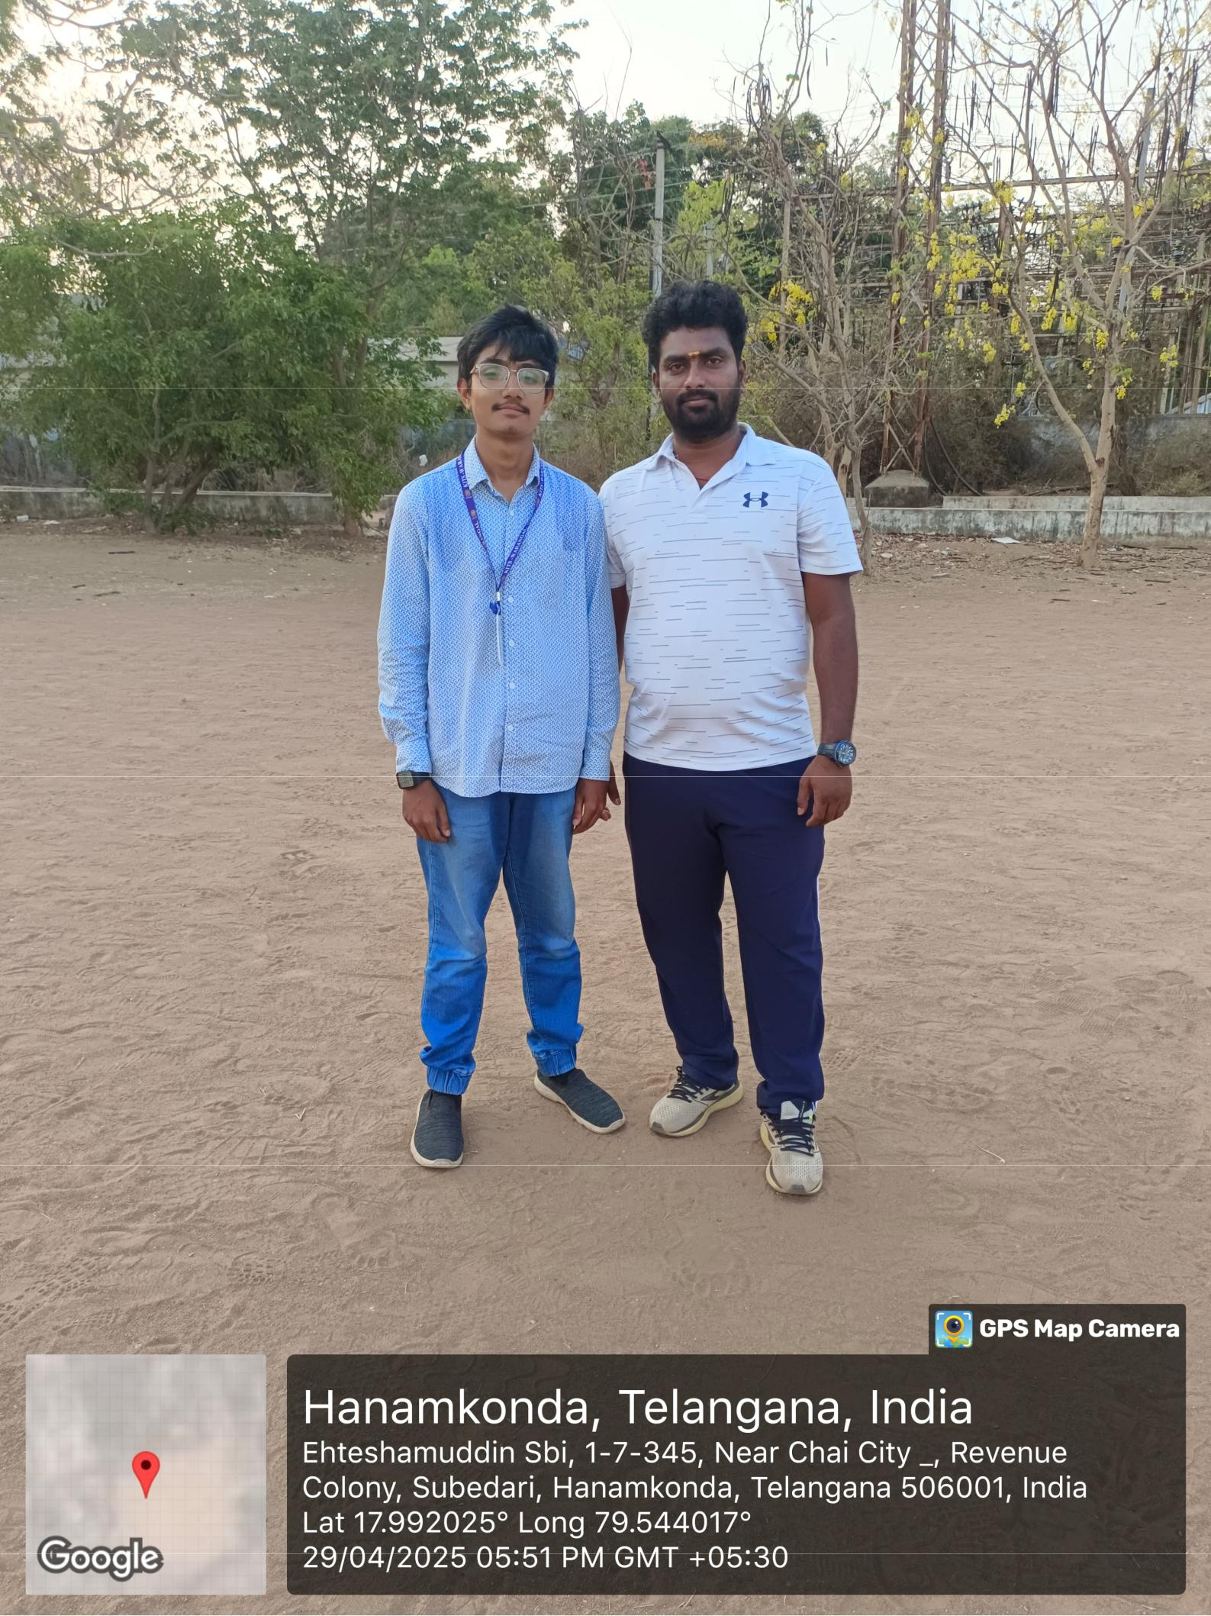

2.3. **Surveys/ seminars/workshops conducted *(optional, as per activity)***

* Not conducted.

2.4. **Workshops/ seminars attended *(optional, as per activity)***

* Not conducted.

2.5. **Practise sessions carried out *(optional, as per activity)***

In this section, I visited indoor stadium for my demonstration. DR. M.S. Reddy evaluated my demonstration and helped through this activity.

2.6. **Summary of field work carried out**

The tasks done were to boost physical and mental stability and help develop fitness. And make the students aware of the outside world.

**CHAPTER 3**

**Demonstration & Presentation**

**3.1. Introduction**

The demonstration was done on 2nd of May , 2025. Dr. M.S. Reddy evaluated the demonstration and the number of attendees were 2 students.

**3.2. Demonstration/ Presentation Content**

The demonstration was to see our physical abilities and evaluate them. We had to shoot the ball and juggle the opponents in the football ground. Dr. M.S. Reddy evaluated the demonstration.

**3.3. Feedback Analysis**

*No feedback given.*

**CHAPTER 4**

**Key Learnings from the Activity**

**4.1.** **Introduction**

Through this football activity, I improved my physical abilities, developed the habit of staying fit, and continued working on exercises that strengthen my body and enhance my game performance.

**4.2.** **Learnings**

***4.2.1. New knowledge and skills acquired during SEA/SAA activity***

The new world skills I acquired were shooting,juggling,stamina increment and masculinity to be fit both mentally and physically.

***4.2.2. Help in professional career***

This activity helped me build and motivated me to be fit which will be very helpful in future aspects of a bright career.

***4.2.3. Improvement in confidence levels***

The activity increased my confidence significantly. Meeting the eminent personalities made me get some outside meeting experience after interviewing them.

***4.2.4. Improvement in decision- making process***

It improved my decision making as I see fitness in every work and try to it as efficiently as possible.

***4.2.5. Positive changes experienced in life***

I learned to practice football daily and trying to become fit has been my goal before the activity and after the activity it has been encouraged a bit.

***4.2.6. Ability on handling rejections***

Yes, my ability to handle rejection has improved as I gained some patience through the activity.

**4.3.** **Relevance to society**

In today’s society, fitness is often overlooked, making it crucial for students to develop a fitness mindset. As the future leaders and innovators, students must prioritize their physical and mental well-being to thrive in the coming era.

**4.4.** **Self-accomplishment**

Through this football activity, I achieved significant progress in improving my overall fitness and performance. I now feel highly motivated to continue building my strength, endurance, and skills for better performance on the field.

|  |  |  |  | **CHAPTER 5** | | |  |  |  |  |  |  |
| --- | --- | --- | --- | --- | --- | --- | --- | --- | --- | --- | --- | --- |
|  |  |  | **Self Reflection** | | | |  |  |  |  |  |  |
|  |  |  |  |  |  |  |  |  |  |  |  |  |
|  |  | **Level** |  | **Standard** | | |  |  |  |  |  |  |
|  |  |  |  |  |  |  | |  |  |  |  |  |
|  |  | 0 |  | Below standards/norms | | | | |  |  |  |  |
|  |  |  |  |  |  |  | |  |  |  |  |  |
|  |  | 1 |  | Needs improvement | | | | |  |  |  |  |
|  |  |  |  |  |  |  |  |  |  |  |  |  |
|  |  | 2 |  | Satisfactory | | |  |  |  |  |  |  |
|  |  |  |  |  |  |  |  |  |  |  |  |  |
|  |  | 3 |  |  | Good | |  |  |  |  |  |  |
|  |  |  |  |  |  |  |  |  |  |  |  |  |
|  |  | 4 |  | Very Good | | |  |  |  |  |  |  |
|  |  |  |  |  |  |  |  |  |  |  |  |  |
|  |  | 5 |  | Excellent | | |  |  |  |  |  |  |
|  |  |  |  |  |  |  |  |  |  |  |  |  |
|  |  | | |  |  |  |  |  |  |  |  |  |
| S. No. | Improvement in Skill | | |  | 0 |  | 1 |  | 2 | 3 | 4 | 5 |
|  |  | | |  |  |  |  |  |  |  |  |  |
| 1. | Intellectual Ability | | |  |  |  |  |  |  |  |  | 5 |
|  |  | | |  |  |  |  |  |  |  |  |  |
| 2. | Oral Communication Skills | | |  |  |  |  |  |  |  |  | 5 |
|  |  | | |  |  |  |  |  |  |  |  |  |
| 3. | Written Communication skills | | |  |  |  |  |  |  |  |  | 5 |
|  |  | | |  |  |  |  |  |  |  |  |  |
| 4. | Maturity | | |  |  |  |  |  |  |  |  | 5 |
|  |  | | |  |  |  |  |  |  |  |  |  |
| 5. | Initiative | | |  |  |  |  |  |  |  |  | 5 |
|  |  | | |  |  |  |  |  |  |  |  |  |
| 6. | Motivation | | |  |  |  |  |  |  |  |  | 5 |
|  |  | | |  |  |  |  |  |  |  |  |  |
| 7. | Ability to work with others | | |  |  |  |  |  |  |  |  | 5 |
|  |  | | |  |  |  |  |  |  |  |  |  |
| 8. | Time management skills | | |  |  |  |  |  |  |  |  | 5 |
|  |  | | |  |  |  |  |  |  |  |  |  |
| 9. | Ability to receive instruction | | |  |  |  |  |  |  |  |  | 5 |
|  |  | | |  |  |  |  |  |  |  |  |  |
| 10. | Ability to receive feedback | | |  |  |  |  |  |  |  |  | 5 |
|  |  | | | |  |  |  |  |  |  |  |  |
| 11. | Resilience when faced with difficulties | | | |  |  |  |  |  |  |  | 5 |
|  |  | | |  |  |  |  |  |  |  |  |  |
| 12. | Respect for self and others | | |  |  |  |  |  |  |  |  | 5 |
|  |  | | |  |  |  |  |  |  |  |  |  |
| 13. | Improvement in self-discipline | | |  |  |  |  |  |  |  |  | 5 |
|  |  | | |  |  |  |  |  |  |  |  |  |
| 14. | Improvement in self-confidence | | |  |  |  |  |  |  |  |  | 5 |
|  |  | | | |  |  |  |  |  |  |  |  |
| 15. | Improvement in handling rejections | | | |  |  |  |  |  |  |  | 5 |
|  |  |  |  |  |  |  |  |  |  |  |  |  |

**Appendix-A**

(Include the Questionnaire for interaction with eminent personalities)

**Name : Nagaraj sir**

**1. What is your personal football training routine and how do you stay consistent?**

As a football player, my routine focuses on improving my skills, strength, and stamina. I follow a weekly schedule that includes:

* + Mon: Dribbling & ball control
  + Tue: Strength training & lower body exercises
  + Wed: Active recovery & flexibility drills
  + Thu: Passing & shooting practice
  + Fri: HIIT + agility drills
  + Sat: Match simulation & tactical play
  + Sun: Rest or light mobility work

I stay consistent by setting daily goals, maintaining proper nutrition, and keeping track of my progress. Consistency comes from discipline and treating practice like a scheduled commitment. Most importantly, I believe that "football is a lifestyle," where every practice contributes to personal and team growth.

1. **How important is nutrition in football performance?**

Nutrition plays a crucial role in football performance. Here’s why:

* + **Energy**: Proper nutrition fuels intense training and match performance.
  + **Recovery**: Protein, carbs, and fats aid in muscle repair and recovery post-training.
  + **Endurance**: A balanced diet supports long-term stamina, critical for full matches.
  + **Focus**: Healthy eating enhances mental clarity, essential for in-game decision-making.
  + **Injury Prevention**: Proper nutrition supports bone health and reduces injury risks.

"You can’t out-train a poor diet." Nutrition is the backbone of sustained football performance.

1. **How can a football player maintain a consistent training regimen?**

A football player can maintain a good fitness regimen by:

* **Scheduling sessions**: Treating training sessions like important appointments.

* + **Varying the workouts**: Including technical drills, physical conditioning, and match simulations.
  + **Consistency over intensity**: Consistent, focused practice is better than occasional intense sessions.
  + **Eating well**: A balanced diet aids in muscle building and recovery.
  + **Rest and recovery**: Giving the body time to heal is essential for continuous progress.
  + **Smart planning**: Incorporating football into daily life ensures regularity.

1. **What advice do you have for beginners who want to start their football journey?**

Start with the basics: focus on fundamental skills such as passing, dribbling, and shooting. Set small, achievable goals and gradually increase intensity. Consistency is key—don’t worry about perfection, just keep practicing and focus on progress. Football is a journey, and every session contributes to improvement.

**5. What are the best football drills for overall strength and endurance?**

The best football drills for strength and endurance include:

* + **Sprints & agility drills** for speed and quickness
  + **Ball control drills** for better coordination
  + **Plyometrics (jump squats, box jumps)** for explosive strength
  + **Core exercises (planks, Russian twists)** for stability
  + **Long-distance running** for cardiovascular endurance

These drills build overall fitness, agility, and stamina essential for match performance.

1. **What role does sleep play in football training and recovery?**

Sleep is vital for recovery in football. It allows the body to repair muscles, replenish energy stores, and maintain hormonal balance. Without sufficient sleep, performance, focus, and recovery will be hindered, affecting both physical and mental preparation for matches.

**7. What are the basic football skills every player should master?**

Basic football skills that every player should master include:

* **Passing & receiving**: Effective ball movement

* + **Dribbling**: Keeping control while evading defenders
  + **Shooting**: Accurate and powerful strikes on goal
  + **Defensive positioning**: Blocking and intercepting passes
  + **Heading**: Both defensive and offensive use of the head in play

Mastering these skills is essential for effective match participation and team contribution.

1. **How does football training contribute to overall physical fitness?**

Football training boosts endurance, strength, speed, and agility, while also improving coordination and mental focus. It’s a full-body workout that increases cardiovascular health and builds muscle. Football also improves teamwork, decision-making, and communication under pressure, contributing to overall fitness and mental well-being.

**9. Can football performance improve without advanced strength?**

Yes, football performance can improve without advanced strength. Success in football relies on technique, game awareness, and tactical understanding. Focused training on ball skills, positioning, and strategy can elevate performance even without high levels of physical strength.

**10. What is key to success in football?**

Success in football is driven by **consistency**, **discipline**, and **teamwork**. A player needs to understand the game’s tactics, maintain a positive mindset, and be willing to learn and adapt. Technique, fitness, and good communication on the field are the foundation of a successful football career.

**Appendix -C**

(include the plagiarism report of the report)

